**QUIZ 2: Telling People’s Jobs and Professions II**

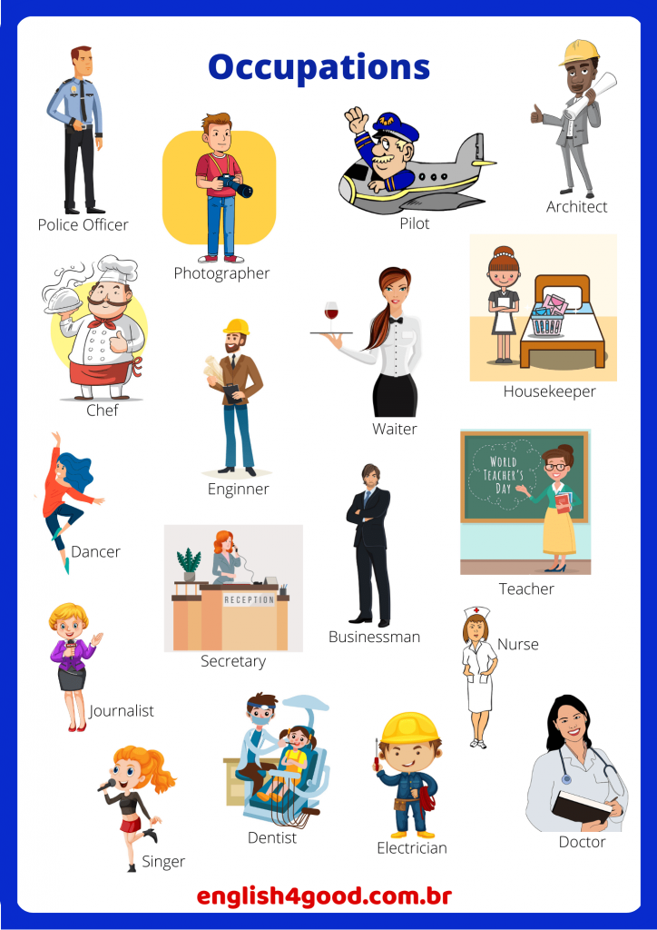

1. Police Officer
2. Baker
3. Fireman
4. Teacher



1. Housewife
2. Journalist
3. Secretary
4. Waiter



1. Doctor
2. Dentist
3. Surgeon
4. Dancer



1. Journalist
2. Engineer
3. Chef
4. Photographer



1. Housewife
2. Nurse
3. Lecturer
4. Housekeeper

Note:

1. Yang dimerahi adalah jawaban yang benar
2. Total poin 100 (1 soal=20 poin)